Project 6
Names: / / .
Graphing

Section I: Polynomials
We begin this section with a question. “What do the roots of a polynomial have to do with its graph?”

You should experiment with your group members until each of you are comfortable with your ability in both WolframAlpha and Maple to sketch graphs, adjust the window size, etc. Ask us for help if you need to.

The Maple command for plotting a 2-dimensional graph of y = a function of x is

plot(function of x, x=xmin..xmax, optional stuff);

This command automatically chooses a y-range that it thinks is best. If you wish to specify the y-range then you must include it in the original command :

plot(function of x, x=xmin..xmax,y=ymin..ymax, more optional stuff);

WolframAlpha accepts the either the command

plot function of x
or
graph function of x

Using WolframAlpha graph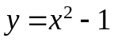. Note, WolframAlpha typically displays two plots: one close up and one further away. For the first plot, what are the ranges on x and y?
xmin = -1.25 xmax = 1.25 .
ymin = -1.05 ymax = 0.45 .

For the second plot, what are the ranges on x and y?
xmin = -2.5 xmax = 2.5 .
ymin = -1.05 ymax = 5 .

Do the same thing for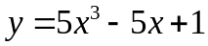. Again, WolframAlpha typically displays two plots: one close up and one further away. For the first plot, what are the ranges on x and y?
xmin = -1.5 xmax = 1.5 .
ymin = -7 ymax = 7 .

For the second plot, what are the ranges on x and y?
xmin = -2.5 xmax = 2.5 .
ymin = -40 ymax = 38 .

Note, WolframAlpha will accept optional range constraints for either x or y or both. The command takes the form:

plot function of x, x= xmin..xmax, y=ymin..ymax

When the optional range constraints are added only one plot is displayed. Using WolframAlpha, graph the same function and specify both x and y range constraints. Identify the range parameters you specified and copy the sketched the graph to the box below.

xmin = -5 xmax = 5 .
ymin = -20 ymax = 20 .

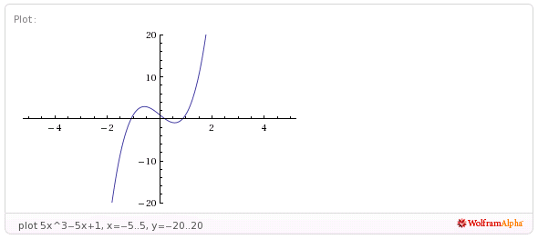

Now use Maple to draw the same graph from xmin=-10 to xmax=10. What is Maple's choice for the range of y-values?
ymin= -5000 and ymax = 5000 .

Now redraw the graph choosing ymin=-10 and ymax=10. Which is the best picture?

The second

Compare the Maple picture with the range (perspective) "constrained" (click on the graph the choose 1-1 from the graph toolbar). Can you achieve the same effect using WolframAlpha?

Click on the graph and experiment with the other options in the graph toolbar of Maple.

Back to our original question: “What do the roots of a polynomial have to do with its graph?” Use both the WolframAlpha and Maple to draw the graphs of

What is the relation between the roots of these polynomials and their graphs?

Notice in Maple you can "position" the cursor/pointer at the x-intercept (as best you can by "eye-balling" it) and then click the mouse – Maple will then report the coordinates of the point you clicked. Is there a similar feature in WolframAlpha?

For purpose of demonstration it is nice to see all these graphs on the same axes. In WolframAlpha, you can list multiple functions to graph on the same axes:

plot first function of x, second function of x, etc.

Again, WolframAlpha will display two graphs with different range parameters.

Plot the above five listed functions on the same axes. Identify the range parameters WolframAlpha returns for the closer graph and copy the sketched graph:

xmin = -1.5 xmax = -1.5 .
ymin = -2 ymax = 4 .

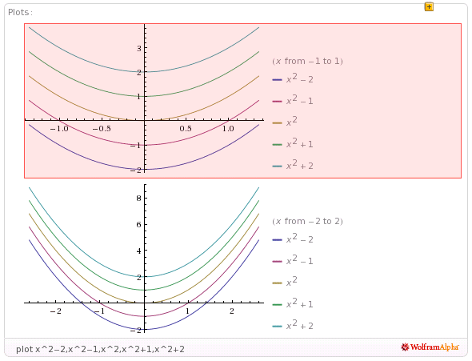

In Maple it seems to be a bit more of a challenge, so here goes. In Maple try the command

plot({x^2-2,x^2-1,x^2,x^2+1,x^2+2}, x=-4..4, y=-10..10);

Actually this is more sensible than it first appears. The symbol { } denotes a set of objects in Maple. So you just asked Maple to graph the set of functions, all on the same axes. A somewhat shorter version of the same Maple command is

plot({seq (x^2+k,k=-2..1)}, x=-4..4, y=-10..10);

Try it. To title your graph insert , title= “whatever” as the optional stuff. Copy the graph by highlighting it, press Ctrl C and paste it into the text box below using Ctrl V. If the graph is too big to fit into this box go back to it in Maple, highlight it and drag a corner to reduce its’ size until it does fit.

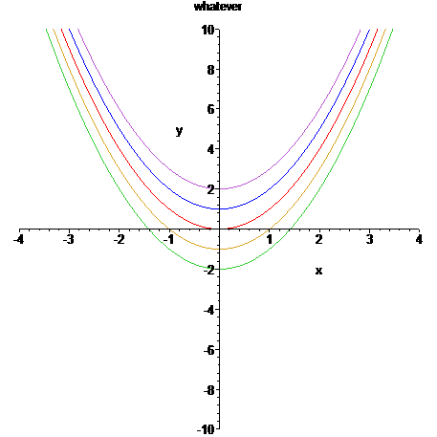
Maple Hint: If you haven't already discovered it, you can often save yourself some time by defining an expression you will use several times as a letter, e.g.,

f:=expression;

Then instead of having to retype the expression every time you need it, you just type f .

Exercise: Using both WolframAlpha and Maple to plot the graphs of the functions

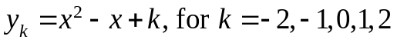

Identify the range parameters and copy the sketched graph (from one of the CAS programs) into the text box below:

xmin = -4 xmax = 4 .
ymin = -10 ymax = 10 .

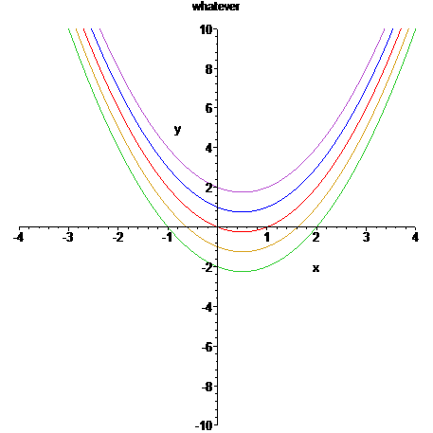

Which of the graphs have only complex roots? x^2-x+1,x^2-x+2

X^2-x-2,x^2-x-1,x^2-x
Which of the graphs have real roots?

Using the cursor/pointer in Maple, estimate the minimum value of each graph.
y₋₂min= -2.22 y₋₁min= -1.26 y₀min= -0.26 y₁min= 0.74 y₂min= 1.75.

Finally use the Maple command subs(x=1/2,yi); for each i and record your results:
y₋₂(.5)= -2.25 y₋₁(.5)= -1.25 y₀(.5)= -0.25 y₁(.5)= 0.75 y₂(.5)= 1.75.

How did I know without ever looking at the graph that the minimum occurs at exactly x=1/2? (The answer lies in Calculus, do you remember?)
Derivative = 0 at x = 1/2
Exercise: Graph 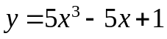using both programs. Adjust the range if necessary to obtain a reasonable picture with Maple. In particular, focus on the
x-intercepts.

Use these range settings to obtain the comparable Maple picture. Estimate the roots (the x-intercepts).
-1.10 & 0.21 & 0.88 . .
Maple estimates are

How do these compare to the roots you find using the solve capabilities of the Maple?
-1.088, 0.209, 0.8788
Can you find a number M so that the polynomial 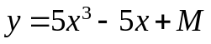has no real roots? (Adding a positive M has the effect of raising the graph.) Explain.
No, because it is a cubic

M=
Using both programs, graph each of the following polynomials. In each case estimate the real roots and if possible find a number M which added to the polynomial produces one with no real roots.(In other words, how much do you have to raise or lower the graph so that it doesn’t cross the x-axis?)

1. 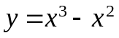
roots~ 0, 0.99 M= none.

2. 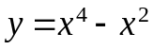
roots~ -1,0, 1 M= 0.8 .

3. 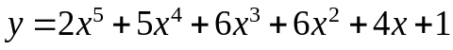
roots~ -0.24 M= none .

4. 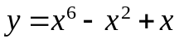
roots~ -1.17, 0 M= 1.2 .

Exercise: It appears that we can find such M for the even degree polynomials but we can not for the odd degree polynomials. Explain why you think this might happen.
Range of odd polynomials goes from –infinity to infinity.
Section II: Rational Functions

Use both programs to graph the rational function 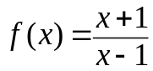. Paste in a labeled printout of one of the graphs in the textbox below. (You might need to play with the range of x and y values to get a good Maple picture.)
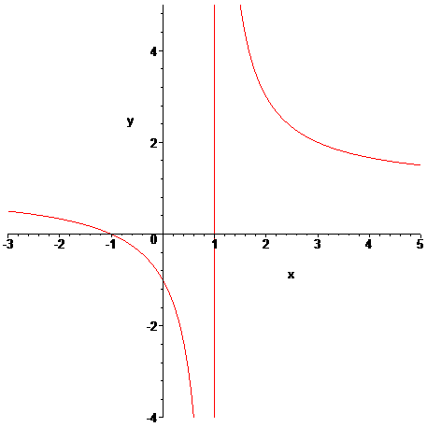

What happens near x=1?
There is an asymptote

Why?
Denominator goes to 0
Can you explain the presence of the vertical line at x=1 on the graphs?
Maple connects points
To answer these questions record the corresponding y values for the x values in this table (substitute x into the function f to obtain y)

x | y
.7 | -5.6666
.8 | -9
.9 | -19
1 | Division by zero
1.1 | 21
1.2 | 11
1.3 | 7.6666

What happens to the y values as the x values get very close x=1 from the left?
They go to minus infinity
What happens to the y values as the x values get very close x=1 from the right?
They go to plus infinity
What happens to the y values as the x values get very large?
They get close to 1
We say f has a "vertical asymptote" at x=1 and a "horizontal asymptote" y=1.

If you simplify 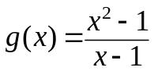what do you get?
g(x) = x+1

Is it true that 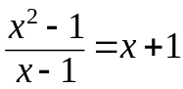 for every value of x?
No, not at x=1

Now use both programs to graph . Insert a labeled picture.
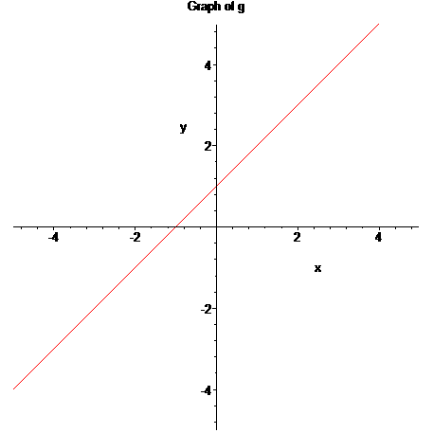

Note that g does not have a horizontal asymptote but does have something we call a "slant asymptote" (a line that approximates the y values for large x values).

Using both programs graph each of the following rational functions and insert the picture. Determine the vertical and horizontal asymptotes, if any.
- 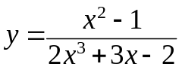
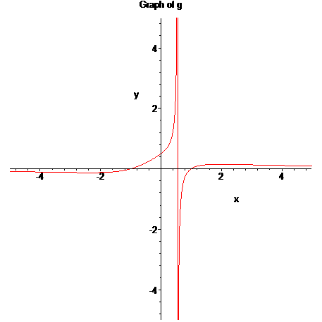

vertical asymptotes at x=0.57 & horizontal asymptote y=0 . .
2. 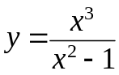

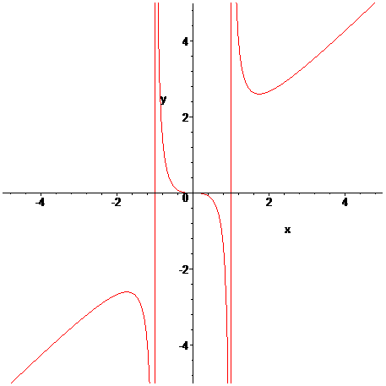

vertical asymptotes at x=-1, x=1 & horizontal asymptote none .
This is as good a time as any to talk about how a machine draws a graph. Unless told to do otherwise the machine samples various values of x between xmin and xmax, computes the corresponding values of y and lights the appropriate pixel on the axes, then connects the dots for adjacent x's with a straight line, hence the presence of the vertical asymptotes drawn above. Sometimes it is instructive to turn off this feature and see only the data points. In Maple, click on the graph then click on the appropriate button in the graph toolbox. Try this for the above graphs and insert printouts in point style for #1 and #2.
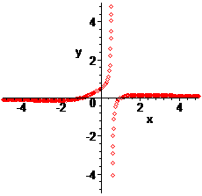
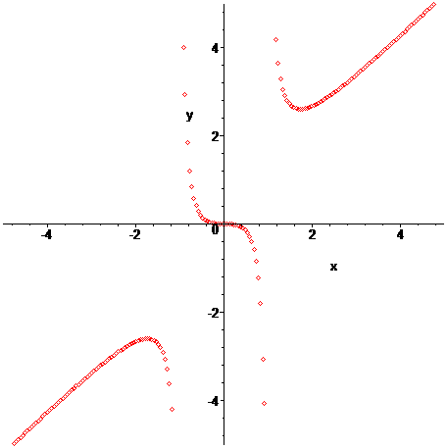

#1 #2
A careful look at these graphs in point style might point out the way Maple chooses them. Maple uses an adaptive sampling procedure that computes more sample points at places where Maple deems the graph to exhibit more interesting phenomenon. What portions of the graphs of #1 and #2 above does Maple seem to find more interesting?
Near flatter portions of the graph

Section III: Implicit Graphs

Implict plots are sketch of graphs of equations that are not functions. Such things are very common; for examples, ellipses, hyperbolas, and many parabolas are such. These are graphs of equations, not necessarily graphs of functions. To graph such things with Maple we must first invoke a special graphing package, to do this execute the command
with(plots);

Notice all the plotting commands contained in this package. Now change the semicolon to a colon and see what happens when you press enter. The implicit plot works just the same as plot did above except the command is

implicitplot(equation in x and y, x=a..b, y=c..d, title=’stuff’);

Using Maple, graph the equation 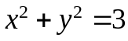 with -2< x <2, -2< y <2. Insert the picture.
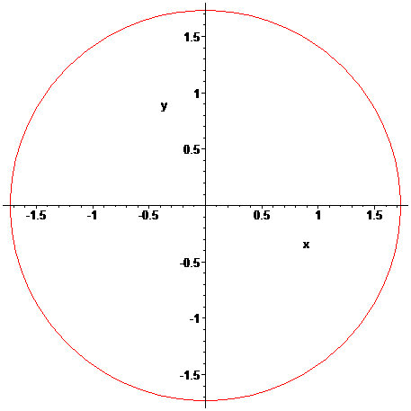
Note that we must put limits on both the x values and the y values. Why do you think this is so?
So it knows what ranges to consider
Try the same command in Maple, but for the equation 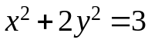. Were the graphs the same? No

In WolframAlpha, one enters the command

implicit plot equation in x and y

Or the command
contour plot equation in x and y

Using WolframAlpha, graph the equation . Insert the picture.
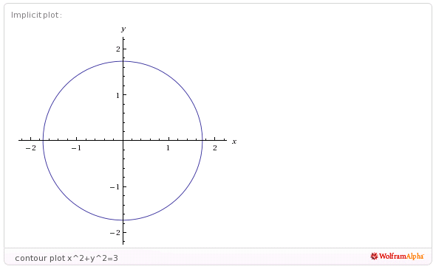
Try the same command in WolframAlpha, but for the equation 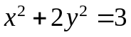. Were the graphs the same? No.

Now graph the following conics on the same axes in 1-1 perspective:

Insert your picture.
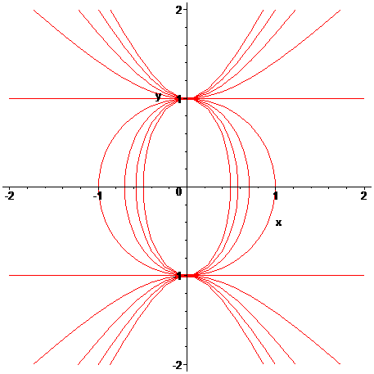

Section IV: 3-d Graphing
The Maple command for plotting a 3-dimensional graph is

plot3d(function in x and y, x=xmin...xmax, y=ymin...ymax, optional stuff);

The WolframAlpha command is

plot function in x and y

The most direct advantage of using Maple is that we can visually drag the graph around to see it from different viewpoints.

Plot the graph of 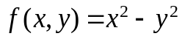 in both Maple and WolframAlpha. In Maple set ranges for x and y from -3 to 3. Also, in Maple click on the graph and drag it around to see different views. Also, click on the graph and experiment with the different buttons on the graph tool bar to see their various effects. (This is really neat stuff!)

Do the same things for the function 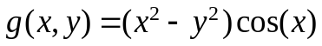.

Insert a picture of a “neat” 3-d graph in the textbox below.
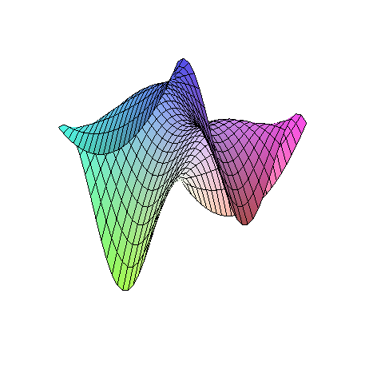
Reflection: What is the most confusing thing about graphing with Maple?

